|  |  |  |  |
| --- | --- | --- | --- |
| |  | | --- | |  | | HOW DO YOU  GET TO  H A P P Y  FROM HERE? | |  | |
| By: Denise Yeargin, M.Ed  MNPS Professional School Counselor  2014 Blue Ribbon Teacher  NLP Practitioner; Avatar Master  Licensed Clinical Hypnotherapist  Ordained Unity Minister  Happy Mad Sad Scared      Creating a New Perspective  A Paradigm Shift  What’s wrong to What’s right   1. Happiness is a Choice – 1978   Frank Minirth and Paul Meier   1. Martin Seiligman – 1998   University of Pennsylvsnia  Positive Psychology   1. Harvard University – 2002   Happiness 101 –“Science of Happiness”   1. Over 200 college classes in U.S. – 2014   How could we do this as a part of guidance curriculum?  P E R M A  Pleasure: What things do you enjoy doing? Skills and Talents  Engagement: How can I assist you in finding ways to join into activities that bring you pleasure?  Relationships: Who in your life supports you? Friends Mentors  Meaning: What gives your life meaning? What are you involved in that is bigger than you? Service Projects  Accomplishments: How do you celebrate your accomplishments?  If you’re happy and you know it:  If you’re sad and you know it:    If you’re mad and you know it: |

If you’re scared and you know it:

WHY USE THIS METHOD?

“The meaning of any great idea lies in the observable practical consequences.”

William James

Children who understand their feelings and learn how to handle their emotions:

1. Form stronger friendships with other children
2. Calm themselves down more quickly
3. Do better in school
4. Begin to handle their moods and negative emotions
5. Bounce back from strong emotional events
6. Get sick less often

John Gottoman PhD

Talaria Research Institute

[www.talaria.org](http://www.talaria.org)

[www.parentingcounts.org](http://www.parentingcounts.org)

Data Notebook: Teaches another level of responsibility

Your Thoughts Create Your Emotions!

It's not your circumstances that create your emotions; Its how you choose to experience your reality.

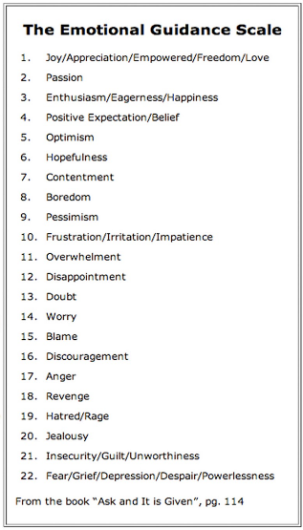

RESOURCES:

“Raising a Conscious Child” by Denise Yeargin

Articles on website: [www.dreamaworldedu.org](http://www.dreamaworldedu.org)

Teaching Children the Art of Living

Wake Up and Live the Life You Love in Spirit

3 dozen leaders explain the power of accepting your

role in the world. Chapter: “Where You Keep Your Focus”

By: Denise Yeargin

Space to add others discussed in workshop: