Mustang Memo | Mustang Memo
Mustang Memo | Mustang Memo
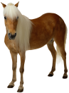  POST CARD  ___________________________  ___________________________  ___________________________ | POST CARD  ___________________________  ___________________________  ___________________________
POST CARD  ___________________________  ___________________________  ___________________________ | POST CARD  ___________________________  ___________________________  ___________________________

