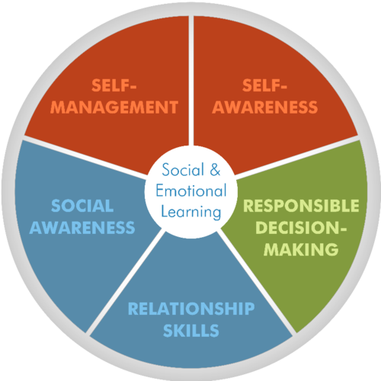

Self-Awareness
Description | Skills Related to Self-Awareness
Self-awareness is the ability to recognize one’s own feelings, interests, and strengths, in addition to maintaining an accurate level of self-efficacy. Students who are self-aware are capable of describing and understanding their own emotions. In addition, they are capable of recognizing their own strengths and weaknesses. Students’ beliefs about their own strengths and weaknesses influence the academic choices they make, how long they will persist on tasks, and whether or not they will ask for help on academic tasks. | - Label and recognize own and others’ emotions Identify what triggers own emotions  - Analyze emotions and how they affect others  - Accurately recognize own strengths and limitations  - Identify own needs and values  - Possess self-efficacy and self-esteem
.
Self-Management
Description | Skills Related to Self-Management
Self-management skills allow individuals to handle daily stresses and control their emotions under difficult situations. Students’ capacities to regulate their emotions impact student memory and the cognitive resources they use on academic tasks. Self-management skills include the ability to monitor and reflect on personal and academic goal-setting. Academic self-regulation has important implications for student motivation in the classroom, as well as the learning strategies students use to master material. | - Set plans and work toward goals  - Overcome obstacles and create strategies for more long-term goals  - Monitor progress toward personal and academic short- and long-term goals  - Regulate emotions such as impulses, aggression, and self-destructive behavior  - Manage personal and interpersonal stress  - Attention control (maintain optimal work performance)  - Use feedback constructively  - Exhibit positive motivation, hope, and optimism  - Seek help when needed  - Display grit, determination, or perseverance  - Advocate for oneself

Social Awareness
Description | Skills Related to Social Awareness
Social awareness allows individuals to take others’ perspectives into account and to empathize with others. Socially aware students are more likely to recognize and appreciate the similarities and differences of others. Social awareness is particularly important for students as they participate in new instructional shifts. Students need to take the perspectives of their classmates during classroom discussions and attempt to empathize and relate with characters during analysis of texts. | - Identify social cues (verbal, physical) to determine how others feel  - Predict others’ feelings and reactions  - Evaluate others’ emotional reactions  - Respect others (e.g., listen carefully and accurately)  - Understand other points of view and perspectives  - Appreciate diversity (recognize individual and group similarities and differences)  - Identify and use resources of family, school, and community

Relationship Management
Description | Skills Related to Relationship Management
Relationship management allows students to develop and maintain healthy relationships with others, including the ability to resist negative social pressures, resolve interpersonal conflict, and seek help when needed. Students need to be able to work well with their classmates in order to participate in collaborative groups. | - Demonstrate capacity to make friends  - Exhibit cooperative learning and working toward group goals  - Evaluate own skills to communicate with others  - Manage and express emotions in relationships, respecting diverse viewpoints  - Communicate effectively  - Cultivate relationships with those who can be resources when help is needed  - Provide help to those who need it  - Demonstrate leadership skills when necessary, being assertive and persuasive  - Prevent interpersonal conflict, but manage and resolve it when it does occur  - Resist inappropriate social pressures

Responsible Decision Making
Description | Skills Related to Responsible Decision Making
Responsible decision making enables students to keep in mind multiple factors—such as ethics, standards, respect, and safety concerns—when making their decisions. This competency includes students’ capacity to identify problems and develop appropriate solutions to those problems, whether they are social or academic problems. | - Identify decisions one makes at school  - Discuss strategies used to resist peer pressure  - Reflect on how current choices affect future  - Identify problems when making decisions, and generate alternatives  - Implement problem-solving skills when making decisions, when appropriate  - Become self-reflective and self-evaluative  - Make decisions based on moral, personal, and ethical standards  - Make responsible decisions that affect the individual, school, and community  - Negotiate fairly
Source: Center on Great Teachers and Leaders at American Institutes for Research. (2014). Teaching the whole child: Instructional practices that support social-emotional learning in three teacher evaluation frameworks (Revised ed.). Washington, DC: Nicholas Yoder. Retrieved from: http://www.gtlcenter.org/sites/default/files/TeachingtheWholeChild.pdf

SEL wheel: www.casel.org
DO NOT NEED THIS PAGE… I just couldn’t get rid of it!

