Activity | What words describe the feelings I have about this activity before I start?  What am I confident about?  What am I concerned or confused about?  How ready am I for this activity? | What words describe the feelings I have about this activity now that I finished it?  What did I learn or learn better?  What am I still concerned or confused about?  What do I want to learn more about?

Which face or faces describe you now?
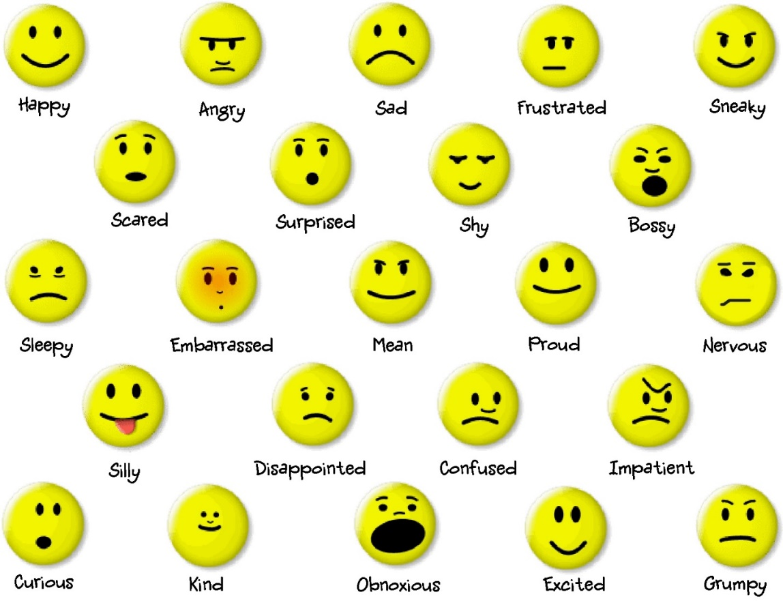
Other:___________________________________________________________________

How strong is that feeling?

Why do you think you have that feeling or feelings?

